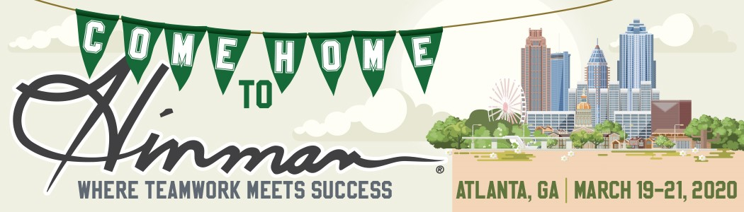
Dear [Manager’s Name]-
I’d like to attend the Hinman Dental Meeting and hope you’ll approve this request.

Hinman offers three days of continuing education where I can earn up to 21 hours of CE in one trip. Topics covered include Infection Control, CPR Recertification, OSHA, Oral Pathology, Medical Emergencies, Team Communications, Health and Wellness….just to name a few! Additional suggested courses for hygienists can be found here.

The “Prevention Convention” course is returning, and a $10 lunch voucher is included in the course fee. Here is that course lineup on Thursday, March 19:
8 - 9:30 a.m. | Dr. Tieraona Low Dog
Boning Up on Osteoporosis: An Update for the Dental Team

9:30 - 11 a.m. | Ms. Judy Bendit
Something to Chew On: The Effects of Aging on Oral Health

12 - 1:30 p.m. |Dr. Samson Ng
Oral Pathology Update for the Hygienist

1:30 - 3 p.m. |Ms. Shannon Nanne
Jump With Me! Take That Step to Treating the Entire Patient, Not Just the Oral Cavity We Are Used To!

Here are some other notable aspects of this event:
- There are more than 400 companies that exhibit at the Meeting, so I can touch and sample it all under one roof.
- 2020 is a Homecoming year and a lot of my colleagues from school will be there so I can catch up with them and learn from their experiences in the practice, as well as learning from the experts during my courses.
- The Hinman’s Night Out party on Friday night is at a new location – the historic Tabernacle!
If I register before February 20th, the registration fee is only $75 (after 2/20/20 it increases to $85). You can learn more about the event and see the full schedule at Hinman.org. Thanks for considering this request to continue learning and growing in my role in the practice.
Sincerely,
[Your Name]

